Overview
 | 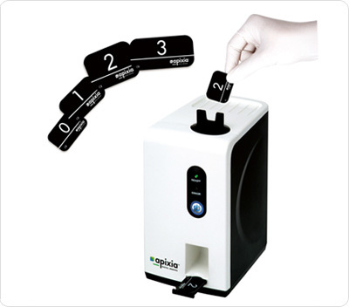
  Small Size, Big Impact
  The Apixia PSP Scanner packs tremendous imaging power into a small package. Tiny enough to fit into the most crowded dental operatories for handy chairside use, yet robust enough to be placed in a central location for use by the entire office, the Apixia PSP Scanner is the ideal product for any size dental practice. Imaging with PSP plates offers all the flexibility and patient comfort of film, combined with the immediacy and environmental benefits of digital radiography. It's truly the best of both worlds.
  Images in Just a Few Easy Steps
  Imaging is fast and simple: Position and expose the flexible PSP plate just like a piece of film, remove it from the hygienic envelope, and drop it into the Apixia PSP Scanner. The smart top-loading design harnesses the power of gravity for simple loading and fuss-free use. In less than ten seconds, the crystal clear radiograph appears on the computer screen, ready for viewing. Then, just simply insert the next exposed plate when ready. The unit's in-line eraser clears the imaging plate for its next use automatically. When the plate is ejected from the bottom of the machine, it's ready for immediate re-use. Plus, plates are reusable thousands of times to maximize your investment. The sturdy design is whisper quiet and vibration free. And, bright LED lights in the machine's front control panel guide users every step of the way.

Specifications
Dimension: | 258 mm x 138 mm x 183 mm
Weight: | 3.6 kg
Voltage Requirements: | AC 100-240 V AC 60/50 Hz
Scan Time: | 10 seconds
Resolution: | 17 lp/mm
USB Cable Length: | 1.8 meters
Connection Type: | USB 2.0
Computer System Requirements:  Note: Computer not included  Windows Versions  Min. RAM  Min. Video  Card Min.  Hard Drive Space  Monitor  Other | Windows XP, Windows Vista, Windows 7 32/64 bit  512 MB, 1 GB recommended  Pentium4 CPU or better  SVGA 1024 x 768  40 GB  High Quality Display (Flat Panel or CRT)  recommended. 1000:1 Contrast Ratio and 0.255 dot  pitch recommended  Backup System highly recommended. High Speed Internet is suggested for enhanced technical support assistance.
Plate Sizes: | Sizes 0, 1, 2, 3
Gray Level: | 14 bit
Limited Warranty: | Two Years Parts and Factory Labor Limited Warranty. See Warranty for more details.
Regulatory: | US FDA, CE, IEC 60601-1, IEC 60601-1-2

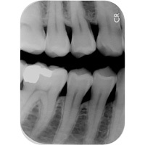 | 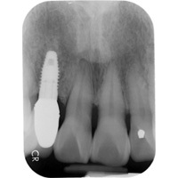 | 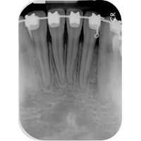 | 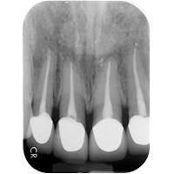
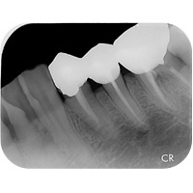 | 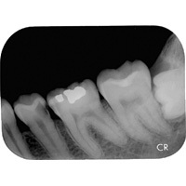 | 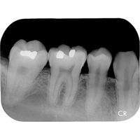 | 

